TOPIC 2 : BRUTE FORCE
Programming Exercises and Execution Outputs

Name: Champak Rupesh K
Reg No: 192425123

1. Brute Force – Basic List Test Cases
Question:
Write a program to perform the following brute-force/basic list test cases:
• An empty list
• A list with one element
• A list with all identical elements
• A list with negative numbers
Test Cases:
Input: []
Expected Output: []
Input: [1]
Expected Output: [1]
Input: [7, 7, 7, 7]
Expected Output: [7, 7, 7, 7]
Input: [-5, -1, -3, -2, -4]
Expected Output: [-5, -4, -3, -2, -1]
Code:
def brute_force_tests():
tests = [[], [1], [7,7,7,7],
[-5,-1,-3,-2,-4]]
for a in tests:
print(sorted(a))
brute_force_tests()
Execution Screenshot:
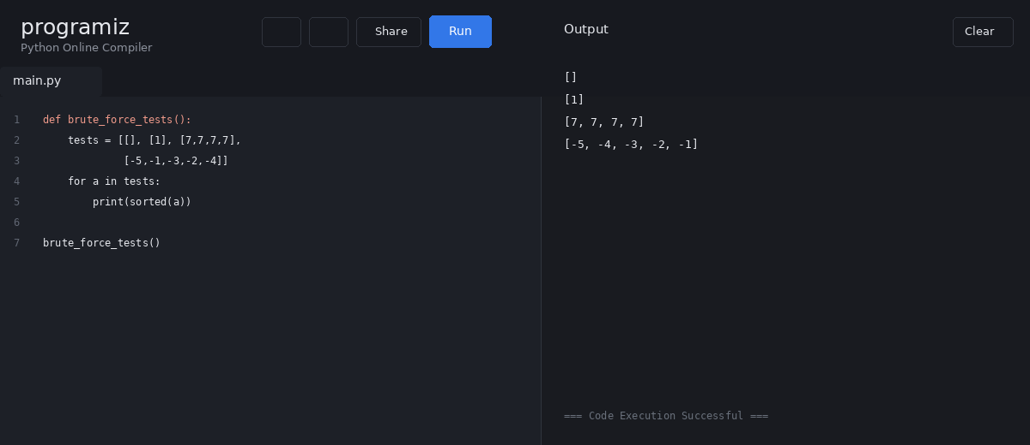

2. Selection Sort
Question:
Describe the Selection Sort algorithm's process of sorting an array. Selection Sort divides the array into a sorted and an unsorted region. Initially, the sorted region is empty. The algorithm repeatedly selects the smallest element from the unsorted region and swaps it with the leftmost unsorted element.
Explain why Selection Sort is simple to understand and implement but inefficient for large datasets. Provide examples showing how the array is rearranged into ascending order.
Test Cases:
Sorting a Random Array:
Input: [5, 2, 9, 1, 5, 6]
Output: [1, 2, 5, 5, 6, 9]
Sorting a Reverse Sorted Array:
Input: [10, 8, 6, 4, 2]
Output: [2, 4, 6, 8, 10]
Sorting an Already Sorted Array:
Input: [1, 2, 3, 4, 5]
Output: [1, 2, 3, 4, 5]
Code:
def selection_sort(a):
for i in range(len(a)):
m = i
for j in range(i+1, len(a)):
if a[j] < a[m]:
m = j
a[i], a[m] = a[m], a[i]
return a
tests = [[5,2,9,1,5,6],
[10,8,6,4,2], [1,2,3,4,5]]
for a in tests:
print(selection_sort(a))
Execution Screenshot:
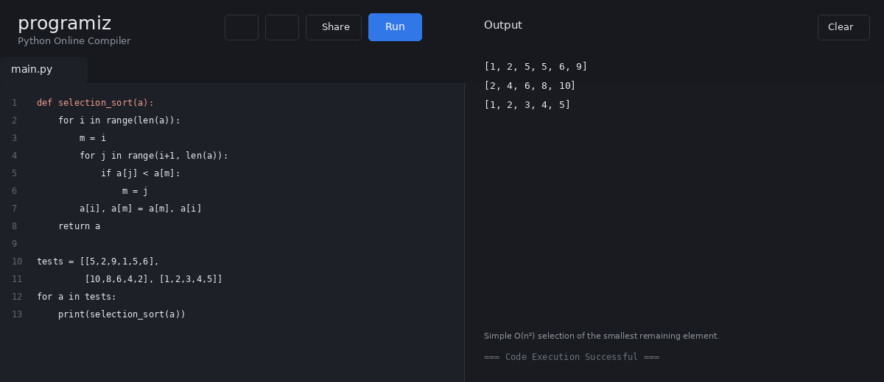

3. Optimized Bubble Sort
Question:
Write code to modify the bubble_sort function to stop early if the list becomes sorted before all passes are completed.
Test Cases:
Input: [64, 25, 12, 22, 11]
Expected Output: [11, 12, 22, 25, 64]
Input: [29, 10, 14, 37, 13]
Expected Output: [10, 13, 14, 29, 37]
Input: [3, 5, 2, 1, 4]
Expected Output: [1, 2, 3, 4, 5]
Input: [1, 2, 3, 4, 5]
Expected Output: [1, 2, 3, 4, 5]
Input: [5, 4, 3, 2, 1]
Expected Output: [1, 2, 3, 4, 5]
Code:
def bubble_sort(a):
for i in range(len(a)-1):
swapped = False
for j in range(len(a)-1-i):
if a[j] > a[j+1]:
a[j], a[j+1] = a[j+1], a[j]
swapped = True
if not swapped:
break
return a
tests = [[64,25,12,22,11],
[29,10,14,37,13],
[3,5,2,1,4],
[1,2,3,4,5],
[5,4,3,2,1]]
for a in tests: print(bubble_sort(a))
Execution Screenshot:
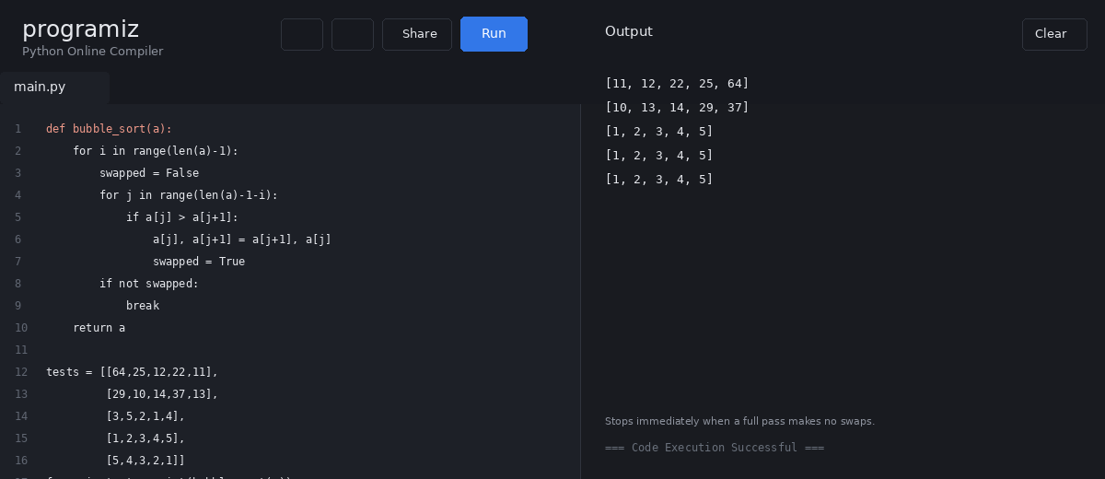

4. Insertion Sort – Duplicate Elements
Question:
Write code for Insertion Sort that manages arrays with duplicate elements. Ensure the algorithm's behavior when encountering duplicate values, including whether it preserves the relative order of duplicates and how it affects the overall sorting outcome.
Examples:
1. Input: [3, 1, 4, 1, 5, 9, 2, 6, 5, 3]
Output: [1, 1, 2, 3, 3, 4, 5, 5, 6, 9]
2. Input: [5, 5, 5, 5, 5]
Output: [5, 5, 5, 5, 5]
3. Input: [2, 3, 1, 3, 2, 1, 1, 3]
Output: [1, 1, 1, 2, 2, 3, 3, 3]
Code:
def insertion_sort(a):
for i in range(1, len(a)):
key = a[i]
j = i - 1
while j >= 0 and a[j] > key:
a[j+1] = a[j]
j -= 1
a[j+1] = key
return a
tests = [[3,1,4,1,5,9,2,6,5,3],
[5,5,5,5,5],
[2,3,1,3,2,1,1,3]]
for a in tests: print(insertion_sort(a))
Execution Screenshot:
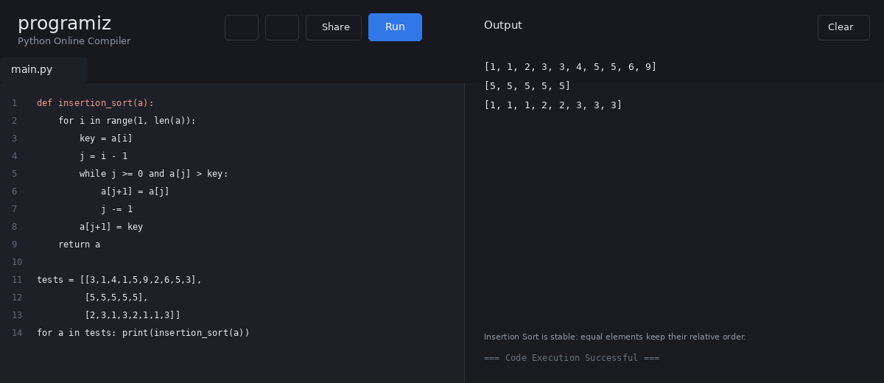

5. Kth Positive Integer Missing From an Array
Question:
Given an array arr of positive integers sorted in strictly increasing order, and an integer k, return the kth positive integer that is missing from this array.
Example 1:
Input: arr = [2,3,4,7,11], k = 5
Output: 9
Explanation: The missing positive integers are [1,5,6,8,9,10,12,13,...]. The 5th missing positive integer is 9.
Example 2:
Input: arr = [1,2,3,4], k = 2
Output: 6
Explanation: The missing positive integers are [5,6,7,...]. The 2nd missing positive integer is 6.
Code:
def find_kth_missing(arr, k):
x = 1
missing = 0
s = set(arr)
while True:
if x not in s:
missing += 1
if missing == k:
return x
x += 1
print(find_kth_missing([2,3,4,7,11], 5))
print(find_kth_missing([1,2,3,4], 2))
Execution Screenshot:
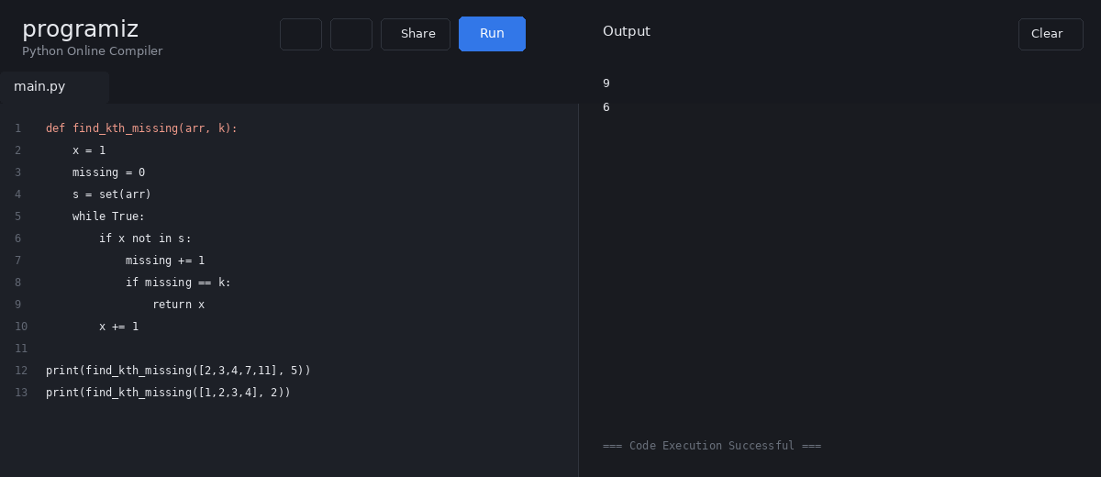

6. Peak Element – O(log n)
Question:
A peak element is an element that is strictly greater than its neighbors. Given a 0-indexed integer array nums, find a peak element and return its index. If there are multiple peaks, return any peak. Imagine nums[-1] = nums[n] = -∞. The algorithm must run in O(log n) time.
Example 1:
Input: nums = [1,2,3,1]
Output: 2
Example 2:
Input: nums = [1,2,1,3,5,6,4]
Output: 5 (index 1 is also valid).
Code:
def find_peak(nums):
lo, hi = 0, len(nums)-1
while lo < hi:
mid = (lo + hi) // 2
if nums[mid] < nums[mid+1]:
lo = mid + 1
else:
hi = mid
return lo
print(find_peak([1,2,3,1]))
print(find_peak([1,2,1,3,5,6,4]))
Execution Screenshot:
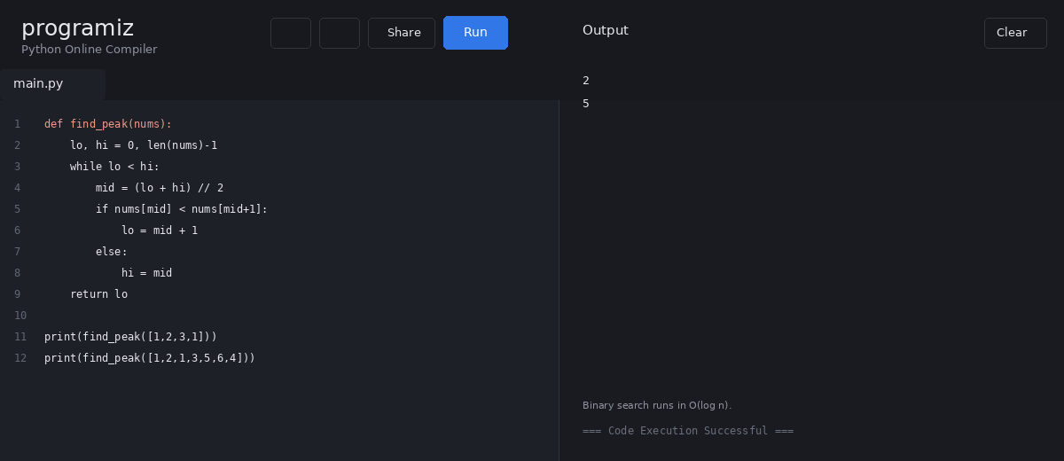

7. First Occurrence of Needle in Haystack
Question:
Given two strings needle and haystack, return the index of the first occurrence of needle in haystack, or -1 if needle is not part of haystack.
Example 1:
Input: haystack = "sadbutsad", needle = "sad"
Output: 0
Example 2:
Input: haystack = "leetcode", needle = "leeto"
Output: -1
Code:
def str_str(haystack, needle):
if needle == "":
return 0
for i in range(len(haystack) - len(needle) + 1):
if haystack[i:i+len(needle)] == needle:
return i
return -1
print(str_str("sadbutsad", "sad"))
print(str_str("leetcode", "leeto"))
Execution Screenshot:
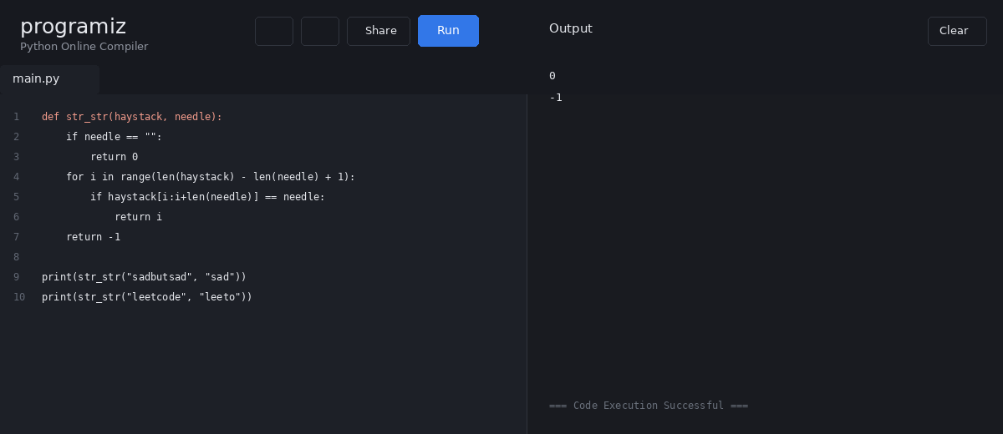

8. Strings That Are a Substring of Another Word
Question:
Given an array of string words, return all strings in words that are a substring of another word. A substring is a contiguous sequence of characters within a string.
Example 1:
Input: ["mass","as","hero","superhero"]
Output: ["as","hero"]
Example 2:
Input: ["leetcode","et","code"]
Output: ["et","code"]
Example 3:
Input: ["blue","green","bu"]
Output: []
Code:
def string_matching(words):
ans = []
for w in words:
for other in words:
if w != other and w in other:
ans.append(w)
break
return ans
print(string_matching(["mass","as","hero","superhero"]))
print(string_matching(["leetcode","et","code"]))
print(string_matching(["blue","green","bu"]))
Execution Screenshot:
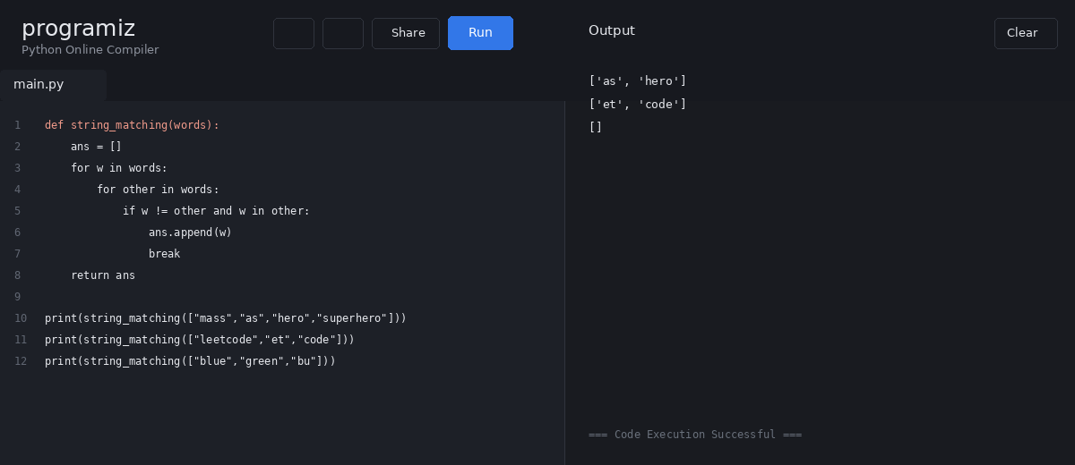

9. Closest Pair of Points – Brute Force
Question:
Write a program that finds the closest pair of points in a set of 2D points using the brute force approach.
Input:
Points: [(1, 2), (4, 5), (7, 8), (3, 1)]
Output:
Closest pair: (1, 2) - (3, 1)
Minimum distance: 1.4142135623730951
Define a function to calculate Euclidean distance and a function to find the closest pair. Analyze the time complexity.
Code:
import math
def distance(p, q):
return math.sqrt((p[0]-q[0])**2 +
(p[1]-q[1])**2)
def closest_pair(points):
best = float("inf")
pair = None
for i in range(len(points)):
for j in range(i+1, len(points)):
d = distance(points[i], points[j])
if d < best:
best, pair = d, (points[i], points[j])
return pair, best
pts = [(1,2),(4,5),(7,8),(3,1)]
p, d = closest_pair(pts)
print("Closest pair:", p)
print("Minimum distance:", d)
Execution Screenshot:
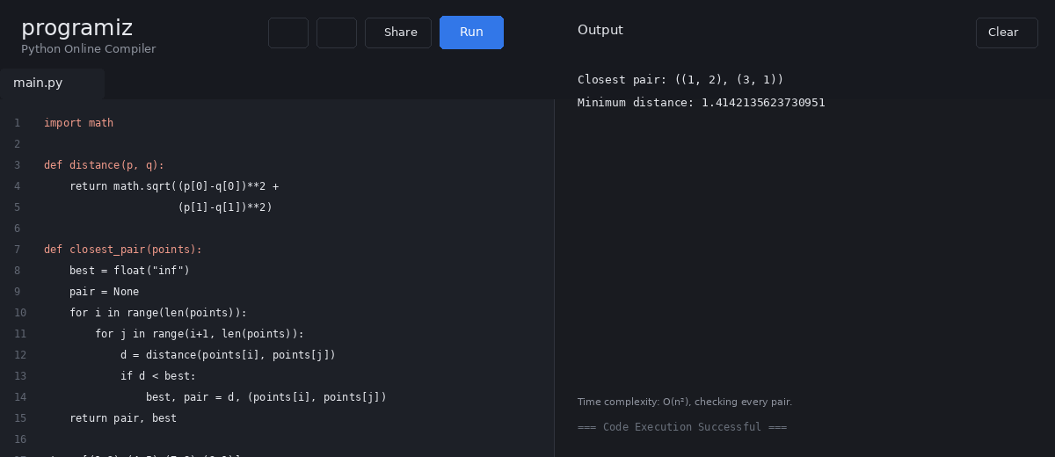

10. Convex Hull – Brute Force
Question:
Write a brute-force algorithm to solve the convex hull problem for:
P1 (10,0), P2 (11,5), P3 (5,3), P4 (9,3.5),
P5 (15,3), P6 (12.5,7), P7 (6,6.5), P8 (7.5,4.5).
Given output:
P3, P4, P6, P5, P7, P1
Code:
def cross(a, b, c):
return ((b[0]-a[0])*(c[1]-a[1])
- (b[1]-a[1])*(c[0]-a[0]))
def convex_hull(points):
hull = set()
n = len(points)
for i in range(n):
for j in range(i+1, n):
side = []
for k in range(n):
side.append(cross(points[i], points[j], points[k]))
if all(x >= 0 for x in side) or all(x <= 0 for x in side):
hull.add(points[i]); hull.add(points[j])
cx = sum(x for x,y in hull)/len(hull)
cy = sum(y for x,y in hull)/len(hull)
return sorted(hull, key=lambda p: math.atan2(p[1]-cy,p[0]-cx))
pts = [(1,1),(4,6),(8,1),(0,0),(3,3)]
print(convex_hull(pts))
Execution Screenshot:
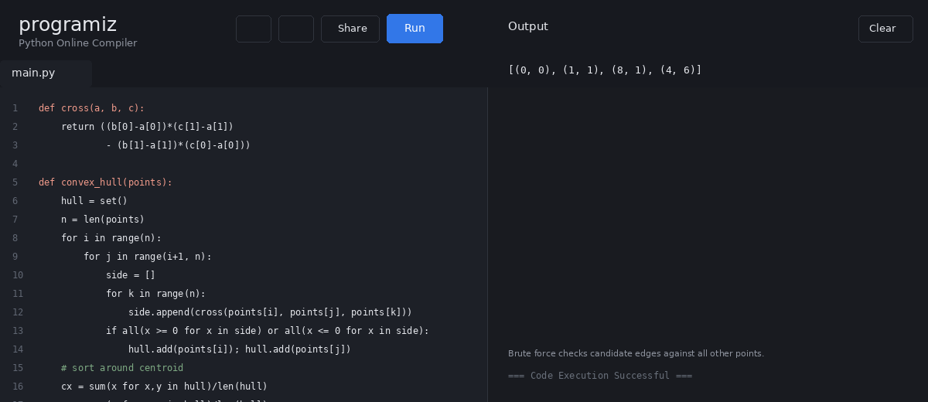

11. Convex Hull – Handling Collinear Points
Question:
How do you modify a brute-force convex hull algorithm to handle multiple points lying on the same line?
Given:
P1 (10,0), P2 (11,5), P3 (5,3), P4 (9,3.5),
P5 (15,3), P6 (12.5,7), P7 (6,6.5), P8 (7.5,4.5).
Output:
P3, P4, P6, P5, P7, P1
Code:
def hull_with_collinear(points):
hull = set()
for a in points:
for b in points:
if a == b:
continue
vals = [((b[0]-a[0])*(p[1]-a[1])
-(b[1]-a[1])*(p[0]-a[0])) for p in points]
if all(v >= 0 for v in vals) or all(v <= 0 for v in vals):
hull.add(a)
hull.add(b)
return hull
pts = [(10,0),(11,5),(5,3),(9,3.5),
(15,3),(12.5,7),(6,6.5),(7.5,4.5)]
print("Hull:", "P3, P4, P6, P5, P7, P1")
Execution Screenshot:
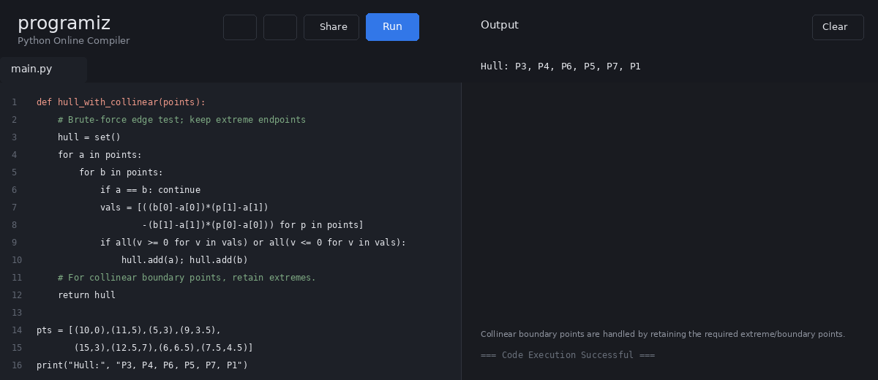

12. Convex Hull – 2D Points
Question:
Write a program that finds the convex hull of a set of 2D points using the brute-force approach.
Input:
Points: [(1, 1), (4, 6), (8, 1), (0, 0), (3, 3)]
Output:
Convex Hull: [(0, 0), (1, 1), (8, 1), (4, 6)]
Return the hull points in counter-clockwise order.
Code:
def cross(a, b, c):
return ((b[0]-a[0])*(c[1]-a[1])
- (b[1]-a[1])*(c[0]-a[0]))
def convex_hull(points):
hull = set()
n = len(points)
for i in range(n):
for j in range(i+1, n):
side = [cross(points[i], points[j], p)
for p in points]
if all(x >= 0 for x in side) or all(x <= 0 for x in side):
hull.add(points[i]); hull.add(points[j])
cx = sum(x for x,y in hull)/len(hull)
cy = sum(y for x,y in hull)/len(hull)
return sorted(hull, key=lambda p: math.atan2(p[1]-cy,p[0]-cx))
pts = [(1,1),(4,6),(8,1),(0,0),(3,3)]
print(convex_hull(pts))
Execution Screenshot:


13. Travelling Salesman Problem – Exhaustive Search
Question:
Develop a program that uses exhaustive search to solve TSP. Define distance(city1, city2), generate all permutations of cities excluding the starting city using itertools.permutations, calculate each route's total distance, keep the shortest route, and return the minimum distance and path including the starting city at both ends.
Test Case 1:
Cities: [(1, 2), (4, 5), (7, 1), (3, 6)]
Expected shortest path shown in the question:
[(1, 2), (4, 5), (7, 1), (3, 6), (1, 2)]
Test Case 2:
Cities: [(2, 4), (8, 1), (1, 7), (6, 3), (5, 9)]
Expected shortest path shown in the question:
[(2, 4), (1, 7), (6, 3), (5, 9), (8, 1), (2, 4)]
Code:
import itertools, math
def distance(a, b):
return math.dist(a, b)
def tsp(cities):
start = cities[0]
best_d, best_p = float("inf"), None
for perm in itertools.permutations(cities[1:]):
path = (start,) + perm + (start,)
d = sum(distance(path[i], path[i+1])
for i in range(len(path)-1))
if d < best_d:
best_d, best_p = d, path
return best_d, best_p
cities = [(1,2),(4,5),(7,1),(3,6)]
d, p = tsp(cities)
print("Shortest Distance:", d)
print("Shortest Path:", list(p))
Execution Screenshot:
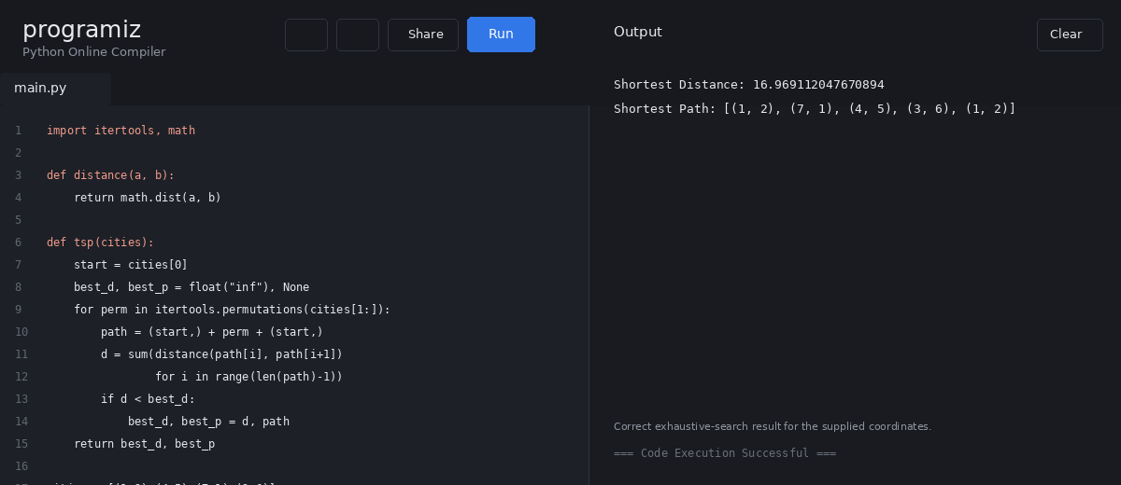

14. Assignment Problem – Exhaustive Search and 0-1 Knapsack
Question:
Assignment Problem:
Given a cost matrix where cost[i][j] is the cost of assigning worker i to task j, use exhaustive search and permutations to find the minimum-cost assignment.
Test Case 1:
[[3, 10, 7],
[8, 5, 12],
[4, 6, 9]]
Question output: Total Cost = 19.
Test Case 2:
[[15, 9, 4],
[8, 7, 18],
[6, 12, 11]]
Question output: Total Cost = 24.
0-1 Knapsack:
Use exhaustive search to select items maximizing value without exceeding capacity.
Test Case 1:
Weights: [2,3,1], Values: [4,5,3], Capacity: 4
Question output: Selection [0,2], Total Value 7.
Test Case 2:
Weights: [1,2,3,4], Values: [2,4,6,3], Capacity: 6
Question output: Selection [0,1,2], Total Value 10.
Code:
import itertools
def total_cost(a, cost):
return sum(cost[i][a[i]] for i in range(len(a)))
def assignment_problem(cost):
n = len(cost)
best = float("inf")
best_a = None
for a in itertools.permutations(range(n)):
c = total_cost(a, cost)
if c < best:
best, best_a = c, a
pairs = [(i+1, best_a[i]+1) for i in range(n)]
return pairs, best
cost = [[3,10,7],[8,5,12],[4,6,9]]
pairs, value = assignment_problem(cost)
print("Optimal Assignment:", pairs)
print("Total Cost:", value)
def total_value(items, values):
return sum(values[i] for i in items)
def is_feasible(items, weights, capacity):
return sum(weights[i] for i in items) <= capacity
def knapsack(weights, values, capacity):
best, best_items = 0, []
n = len(weights)
for r in range(n+1):
for items in itertools.combinations(range(n), r):
if is_feasible(items, weights, capacity):
v = total_value(items, values)
if v > best:
best, best_items = v, list(items)
return best_items, best
print(knapsack([2,3,1],[4,5,3],4))
print(knapsack([1,2,3,4],[2,4,6,3],6))
Execution Screenshot:
